**Everything you want to know about Royal 2025 Filex !**

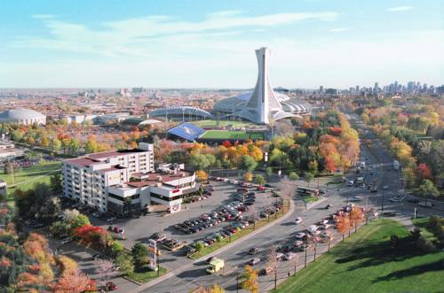The Royal 2025 Filex national philatelic exhibition will take place next April 25 and 26 at Plaza Universel, 5000 Sherbrooke Street East, in Montreal.

This will be the largest exhibition to be held in Canada in 2025! On this occasion, three important anniversaries will be celebrated: the 50th anniversary of the beaver as Canada's animal emblem, the 60th anniversary of the founding of the *Fédération Québécoise de Philatélie* (FQP) and the 100th anniversary of the first national philatelic exhibition to be held on Quebec soil!

The organizing committee has chosen four judges qualified by the *Fédération Internationale de Philatélie* (FIP). Dr. Peter McCann (USA), Mr. Bernard Jimenez (France), Dr. Ian McMahon (Australia) and Dr. Sam Chiu (Canada) will have the pleasant task of evaluating the collections presented in the 150 frames made available to philatelists. For many of them, this will be their last chance to qualify for the next FIP exhibition to be held in Boston in 2026.

At Royal 2025 Filex, several philatelic associations will make presentations, hold assemblies and meetings and organize book launches. These include the Royal Philatelic Society of Canada (RPSC), the *Fédération Québécoise de Philatélie* (FQP), the *Académie Québécoise d'Études Philatéliques* (AQEP), the Canadian Postal History Society, the British North American Philatelic Society (BNAPS), the Philatelic Specialists Society of Canada, *L'art du Timbre Gravé* from France and representatives of the 2026 Boston International Exhibition.

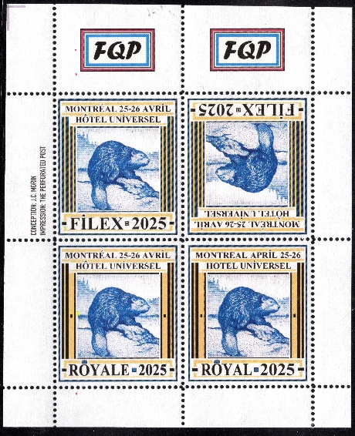A group of FQP volunteers will be in charge of youth activities. Families are invited to bring their children along to learn more about the wonderful hobby of philately. There will be draws every hour and visitors will have the chance to purchase exhibition souvenirs featuring cancellations specially designed by the renowned François Brisse. In addition, limited-edition vignettes celebrating the Canadian beaver will be on sale to visitors. A 60-page full-color program featuring articles on the exhibition different themes will also be available. Much to the delight of philatelists, a number of philatelic dealers from across Canada will be on hand to offer their material and the newest stamp issues.

Parking and admission to the exhibition and activities are free. Plaza Universel is just a few minutes' walk from Viau metro station. We look forward to seeing you there! It's an event not to be missed!

For further information, please write to: [filex2025@outlook.com](mailto:filex2025@outlook.com)